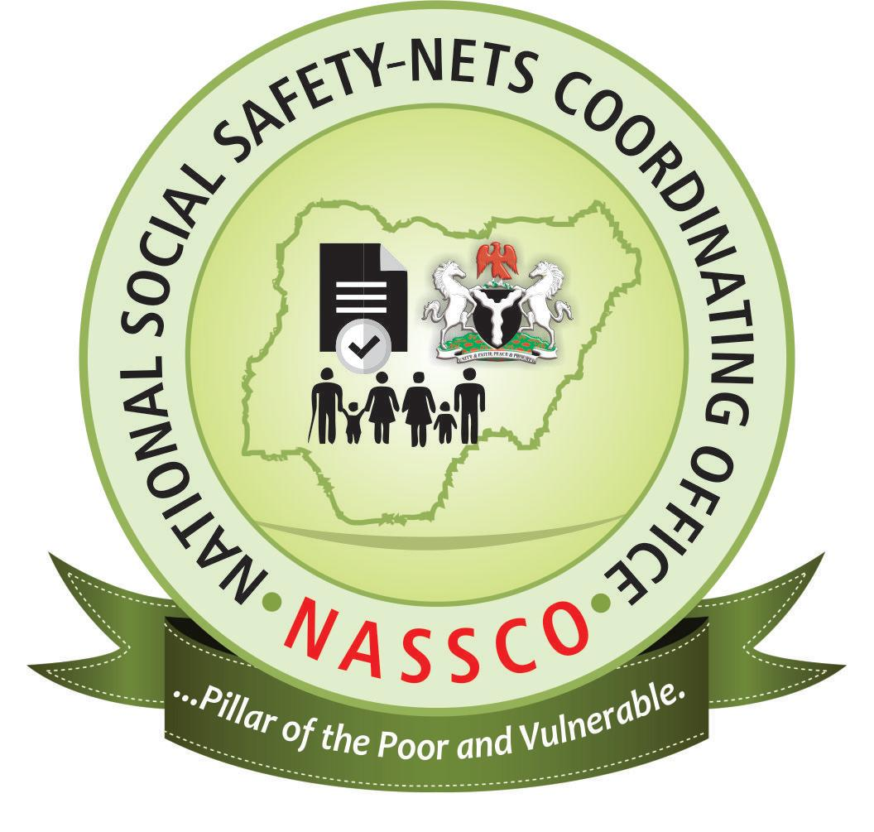
NATIONAL SOCIAL SAFETY NET COORDINATING OFFICE
Terms of Reference
Partial Data Update, Validation and Reallocation of Geo-Coordinates for Poor and Vulnerable Households in the Social Registry

1.0 Background
The Government of Nigeria has prioritized social protection interventions as a key strategy towards reducing poverty and socio-economic vulnerabilities in the country and has partnered with the World Bank under a National Social Safety Nets Project (NASSP) to expand the development of safety nets to poor and vulnerable populations.
The Project Development Objective (PDO) is: to provide access to targeted transfers to poor and vulnerable households under an expanded national social safety nets system. NASSP involves two components: (i) establishing systems for social safety nets that would serve as a robust platform for effectively targeting and delivering social assistance; and (ii) implementing cash transfers to targeted poor and vulnerable households. The program has national coverage, with all states eligible to participate.
To implement NASSP, the Government has established a National Social Safety Net Coordinating Office (NASSCO), under the supervision of the Federal Ministry of Humanitarian Affairs, Disaster Management and Social Development (FMHDSD); to consolidate existing social safety net programs at the Federal level and build the National Social Register (NSR), a database of poor and vulnerable households (PVHHs), which will be used across the country’s different safety net programs, irrespective of funding source or targeted beneficiary group. Different stakeholders, such as governments, development partners, and or civil society will be able to use the systems for delivering social assistance programs in Nigeria.
The NSR is a mirror image of the various State Social Registers (SSR’s) in the 36 state of Nigeria and FCT, and is developed using a combination of three targeting mechanisms:
(a) Geographic targeting: used to identify the poorest Local Government Areas (LGAs) on the basis of poverty indices proposed by the State and validated by NASSCO.
(b) Community-based targeting (CBT): a community led arrangement which amounts to decentralization of the targeting process such that local knowledge of community members is used in identification of PVHHs. This targeting mechanism devolves responsibility to communities to define parameters to define poor and vulnerable households and use same to identify households that fit into their definition. This process involves community sensitization, engagement, and a selection exercise that culminates into a signed list of selected community members that is retained by the community and the same copy kept at the states and federal levels; and
(c) Proxy Means Test: data collection and validation and application of a proxy means test in order to rank households. The PMT is a scripted algorithm that selects a set of variables in the NSR data set that helps to model/predict household welfare and ranks the data set from 1st to 10th decile (1st decile being the poorest and 10th being more well off in relation to the 1st decile)
The Social Register was first established under the Youth Employment and Social Support Operations (YESSO) project since 2014, and since then till date (as at 31st October 2020), the NSR contains 4,963,673 PVHHs across 595 LGAs in all 36 states of the Federation and the FCT.

2.0 Justification for the Activity
The design of the project as captured in the Project Appraisal Document (PAD) and written out in the Project Implementation Plan (PIM), NASSCO’s Operational Manual (OM), the NSR Handbook and other relevant operating procedures describes how and when partial data update and validation will occur to make the NSR a dynamic database. This is not in the sense of permitting continuous registration of PVHHs, but in the need to update the database due to changing circumstances for various reasons, including but not limited to demography, spatial, social and economic mobility, and other natural causes. Broadly, the NSR handbook recommends that the NSR update must be undertaken every three (3) years, and this can be done using two approaches:
- Continuous partial information updates: which arise from three main sources: (a) formal update requests from household or individuals; (b) single registry users’ request for updates; and (c) data exchange with administrative data; and

- Full updates for reassessment of eligibility
However, since the start of YESSO in 2014 (6 years down the line) and NASSP in 2016 (4 years down the line), no update has taken place. As of 2016 when NASSCO (scaled up the social registry beyond the initial 8 YESSO states), the SRs contained a combined data of 139,931 PVHHs from 8 states. From that period till date, a number of modifications has taken place to enhance the quality and integrity including the consolidation of SRs into the NSR, which has led to a significant increase in the NSR, but also important to note is the disparities that these modifications have presented between the old data (from 2014-2017, which will herein be referred to as legacy data) and the new ones from 2017 upwards. Another noteworthy modification to the SSR’s is the change from paper-based interview/data collection method (Paper Based Personal Interview, PAPI) formerly used by YESSO, which came with associated problems of wrong or varied spellings of community names, multiple entries of individual names and biodata, including households within the SR that are found with missing and/or invalid geocoordinates; to an electronic data collection system/method of Computer Assisted Personal Interview (CAPI).
It is also important to note that as part of NASSCO’s effort in ensuring adherence to the relevant process documents, NASSCO has developed data update tools/software, along with a Standard Operating Procedure (SOP) for data update to allow partial and periodic update of the SSR’s. This tool enables users of NSR/SSRs to generate update and share with SOCUs for verification and adoption. This data update application is part of the protocol for data mining and is provided to all users of the SR, including the NASSP Conditional Cash Transfer Programme, the NASSP livelihood pilot, and other development donors/partners funded programmes. Nevertheless, it has been observed that the feedback information from this channel has not been as forthcoming as expected and it is thereby, essential that this protocol is also reviewed and updated to ensure that it is fit for purpose.
Additionally, findings from the internal project monitoring and data back-check exercises have revealed errors in the SR data in some states, including Ebonyi, Plateau, Benue, Nasarawa and Jigawa. This could be attributed to a lot of reasons, stemming from capacity gaps to non/poor compliance of the laid-out processes and procedures for data utilization by NASSCO. While the project is still awaiting the report of the ongoing process evaluation of the targeting mechanisms, a revalidation exercise of the PVHH data in these states is critical; particularly as the project continues to intensify efforts in socializing the SR for increase use.
Therefore, in line with the design of the project and the NSR handbook for partial data update every 3 years but also to address the gaps outlined above, it has now become imperative to conduct a data update exercise that will provide current and accurate status and information on households in the SSR’s and by extension NSR as after 6 years some of the data collected need urgent update because the information collected at the time might be obsolete. Moreover, with the recent transition/handover of the YESSO led/funded states to NASSP, this exercise will also validate the scope and coverage in the select states, and what is left to be covered for complete saturation of all the communities in line with the NASSP Financing Agreement (FA).
Another important feature of the Social Register in Nigeria is the geocoordinates built into the data collection as part of the quality and integrity checks but also for easy tracking of the households in the SSR’s and NSR. This exercise will also further correct some of the geo-coordinate that are wrongly positioned; correct or update community names, individual names, contact information etc.

3.0 Aim and Objectives
The aim of this exercise is to review, update and revalidate the existing SSR data in line with the NASSP NSR Handbook update of every 3 years. Specific objectives of this activity include:
- Review the existing data update SOP, identify gaps, revise/expand and provide recommendations that will improve the buy-in and use of the NSR protocol on data use and update by users.
- Conduct a detailed SSR update including demographic, contact details (phone number, addresses, emails – if any), location (community name, Ward, LGAs, State) of identified and registered Poor and Vulnerable Households and individuals.
- Validate and capture the geocoordinates of the legacy PVHH dataset from YESSO.
- Capacity development of SOCU and the CBT team on the periodic SSR update for ownership of subsequent data updates.
4.0 Scope of Work
This exercise will encompass a full review, update, validation and reallocation of the geocoordinates for all legacy dataset, which cuts across all PVHHs from all YESSO states in the SR from 2017 downwards, with the aim is to update households that has been in the register for 2 years or older. This is comprising of 655,005 PVHHs in 26 states. As part of this batch, the five states of Ebonyi (278,844 PVHHs), Plateau (231,868 PVHHs), Benue (261,359), Nasarawa (234,069 PVHHs) and Jigawa (355,058 PVHHs) will also be included due to their specific challenges of suspected irregularities. This comes to a total of 2,016,203 PVHHs to be updated in this first stage.
The scope of work (SOW) for this Stage 1 will include:
- Review of the existing data update SOP and expansion into a full-fledged protocol/manual and provide recommendations that will improve buy-in and use of the protocol by users.
- Review the data update capturing tool/application
- Refinement of the NSR reference number
- Update of the geocoordinates of the legacy SRs
- Update contact and location information
Based on the NSR governance structure, the SR data belongs to the states while NASSCO facilitates the processes, provides technical support and aggregate the data at the national level. Therefore, it is expected that the selected firm will work closely with the SOCUs to handhold them throughout the update process and provide technical facilitation and supervision for the CBT team to carry out the update, documenting lessons learnt, while also building capacity.
Capacity building is at the center of NASSP. Hence, the implementation of this exercise will also initiate a cross-learning approach, wherein the framework and protocol developed will then be used by SOCUs to conduct similar updates of the SR in outstanding states. This will be an ongoing exercise, which will repeatedly occur once the capacity of the project team has been built and the relevant protocols are in place.

5.0 Approach and Methodology
NASSCO will engage external technical assistance or engage the services of a consultancy firm on a short-term basis, to work closely with the NASSCO/state staff to deliver the SOW as outlined in Stage 1. The firm will design and share a detailed methodology that will be used to achieve the deliverables of the exercise.
Nevertheless, the following steps should provide a guide in designing a methodology:
- Carry out Community sensitization with relevant stakeholders, communicating the need for the exercise
- Use the existing community harmonized list as a baseline for conducting the exercise in agreement with the community stakeholders
- Deploy validation enumerators to carry out the exercise supervised by the firm
- Using the NASSCO data capturing application and data update app; capture and update information of identified PVHHs in each State Social Register.
- Validate all the geocoordinates using appropriate tools such as GIS software, etc. This involves visiting all the affected households and take the coordinates of the households within the premises.
- Convert Coordinate Reference System (CSR) to WGS84 otherwise known as EPGS:4326 for seamless integration with existing data in the NSR.
- Plot GIS on a map (Ward, LGA, states and Nigeria map) to enable zoom in and out.
- Upload the data to a central server for data cleaning and processing by the SOCU MIS
- SOCU MIS forward the data to NASSCO for final checks and update to the NSR

6.0 Deliverables
- Inception Report – Finalized project design and plan detailing the data collection tools, responsibilities and timeline of all the sub-activities. Carry out inventory report of the existing data in the SR and NSR
- Progress Report Shared with NASSCO monthly progress report stating differential variable values and aggregated results in visualizations, maps and write ups that provide operationally relevant results for both updated and existing dataset at zonal, state, local government, ward and community levels.
- Shared updated data: Working closely with the States to share all updated data in the State Social Register and as mirror image with NASSCO
- Final Report – The final report should provide results and conclusions of the entirety of the assignment. It covers design, test and deployment of Data collection tool, data collection and validation, and recommendations, etc.
- Results – complete dataset of all households updated, validated and uploaded onto the Social register including the result of validations such as scripts, code, test data, and validated data.
- Reviewed and updated NSR/data update protocol and recommendations on buy-in and regular usage
- Develop simple MoU to be signed with SSR/NSR users to ensure adherence to laid down protocols on data use
- Plot the update GIS coordinates on a map (Ward, LGA, states and Nigeria map) to enable zoom in and out to enable easy tracing of PVHH

7.0 Desired Consultant Profile
The selected consultant should have the following profile.

7.1. Qualification
The Consultant should have the following qualifications:
  - Well recognized expertise and experience in spatial data analysis and data integration.
  - Expertise and experience development of strategic roadmap for data development.
  - Experience in engaging with multiple stakeholders and generating consensus.
  - Excellent expertise and proven track record in designing and implementing survey especially community-based survey.
  - Self-developed material that can serve as input for this collaboration would be a plus.
  - Ability to work effectively toward tight deadlines and to deliver all deliverables.
  - Demonstrated excellent understanding of the assignment.
  - Direct availability to work on the assignment

7.2. Technical Team Composition
At minimum, the technical team will consist of the following persons:
- Project Manager: at least 10 years’ experience in project Management with a minimum of B.Sc. in Social Science.
- Data Scientist/Statistician: Minimum of B.Sc. in Statistics/Mathematics/Computer Science/Information Science.
- GIS Expert: Minimum of B.Sc. Geographic/Computer Science/Information Science. Must have experience in spatial data analysis.
- Computer Programmer: Minimum of B.Sc. Mathematics/Computer Science/Information Science. With expertise in developing data collection tool.

8.0 Activity and Payment Schedule

This consultancy is a lump sum contract (including VAT), so financial proposals will include all personnel, travel, printing, and other costs associated with this consultancy. The following proportions of the lump sum amount will be paid upon reception of the listed deliverables. The assignment is expected to be conducted over a period of 90 days across 6 months, based on the tentative timeline presented below:
S/N | Activity | Payment | Number of Days
1 | Contract agreement and sign off | 10% | 1
2 | Kick off meeting with NASSCO and SOCUs | 0% | 1
3 | Delivery of Inception Report | 10% | 5
4 | Field Work/Enumeration- MIS Output | 30% | 65
5 | Draft Final Report | 20% | 10
6 | Final Report | 25% | 5
7 | Validation Meeting and Dissemination with States | 5% | 3
 |  |  | 90 Days

9.0 Method of Procurement
Consulting Firm via competitive bidding.

